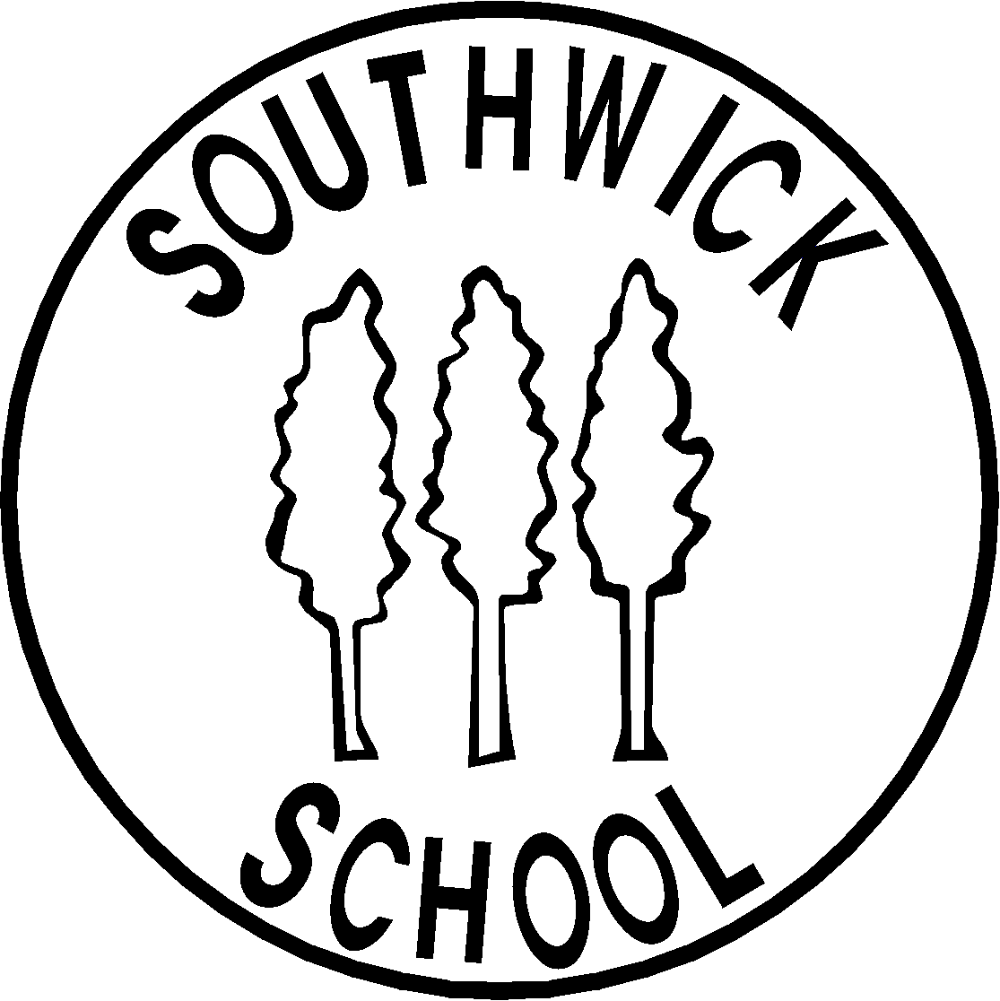

SOUTHWICK CE PRIMARY SCHOOL
Policy and Guidance for Safe Photography and Video Recording in School

This policy is based on guidance issued to schools by Wiltshire County Council in 2013.

RATIONALE
Southwick School welcomes positive publicity. Children’s photographs add colour, life and interest to materials and articles promoting school activities and initiatives and can increase pupil motivation, staff morale and help parents and the local community identify and celebrate the school’s achievements.

Southwick School is committed to safeguarding and promoting the welfare of children and young people and expects all staff and volunteers to share in this commitment. In order to respect young people’s and parents’ rights of privacy and because of potential child protection issues, photographs must be used in a responsible way as technology is making it increasingly easier for pictures and images to be used inappropriately as printed materials or on the web.

Data Protection
Under the terms of the Data Protection Act 2018 photographic images –both digital and film- and video of pupils (or staff) must not be displayed in a public place without consent. This includes publications such as the school prospectus, website or areas in the school where visitors have access.

This policy seeks to achieve a practical balance to secure the above.

General rules on using photographs of individual children
- Parental consent will be obtained before publishing children’s pictures at the start of the school year
- Images of children in suitable dress will be used – photos of children engaged in PE or swimming present a greater risk of potential misuse. In these cases the content of the photograph should focus on the activity, not a particular child; should avoid full face and body shots.
- Where a child is subject to a court order their image will not be used.
- Images will be stored securely and used only by those authorised to do so. Images should be removed after two years
- File names given to electronic images of pupils do not identify the child, e.g.maryjones.jpg
- If consent is given, only the first names of children will be used in publically available electronic or printed communications e.g. magazine articles or school website.

The Media
In order to protect the children, those whose parents have not given permission as outlined above will not be included in any promotion of school activities involving the media.
- If parental consent has been secured newspapers may publish photographs of pupils but must not publish names alongside them. They may however refer to group photographs collectively e.g Shackleton or Southwick’s Year 6 football team.
- Pupils must not be approached or photographed whilst at school (or engaged in school activities outside school) without the permission of the school authorities

Websites
- The parental consent form will explicitly include the publication of images on the school website and on the school’s Facebook page or Twitter feed.
- Where possible the school will use technology to prevent the misuse or downloading of images placed on the school website, e.g. watermarking, browser restrictions

Video & Filming
The appropriateness of photographic images earlier outlined also applies to video/film images. We recognise that parents, carers and family members wish to record events such as school plays, sports days etc. to celebrate their child’s achievements. However, it is important that such records remain private and for their own personal use.

- Upon a child’s admission to the school parents will be asked to sign a form that acknowledges to indicate that any images they take will not be used inappropriately, including the placing of such images on social networking sites
- Parents will be reminded of their responsibility to use images appropriately at events where images are taken by parents.
- Parents may exercise the right to withdraw their children from events where the capturing of images is allowed.

Commercial & Outside Photographers
- Will be given a clear brief about what is considered appropriate in terms of content and behaviour
- Will wear identification at all times and will not have unsupervised access to children or one-to-one photo sessions at events

Parental Consent
On admission of a pupil to the school parents/carers will be asked to sign a consent form which makes clear the school’s policy, especially:
- how and where photographs will be used
- the period of consent
- the storage and deletion of photographs
- We will contact parents/carers annually with the option to change their preferences.

Review
In view of the continual advances in technology, this policy will be reviewed by the Governing Body annually in line with the Child Protection Policy.

